- Include the docstrings documentation

class Queue:
"""
This class implements a first in first out (FIFO) data structure using
two lists: one for enqueuing elements and another for dequeuing elements.
"""

def __init__(self):
"""
Initialize an empty Queue with two internal lists.

Attributes:
a_in (list): Internal list that stores newly enqueued elements.
a_out (list): Internal list that stores elements ready to be dequeued.
"""
self.a_in = []
self.a_out = []

def enqueue(self, d):
"""
Add an element to the back of the queue.

Args:
d: The element to add to the queue. Can be of any type.
"""
self.a_in.append(d)

def dequeue(self):
"""
Remove and return the element at the front of the queue.

Returns:
The element at the front of the queue (the oldest element).
"""
if (self.a_out == []):
for d in self.a_in:
self.a_out.append(d)
self.a_in = []
return self.a_out.pop(0)

2. Convert from python to Java
import java.util.Random;
import java.util.Scanner;
/**
* A Rock Scissors Paper game.
*/
public class RSP {
private static final String ROCK = "r";
private static final String SCISSORS = "s";
private static final String PAPER = "p";

/**
* Main method to run the Rock Scissors Paper game.
*
* @param args command line arguments (not used)
*/
public static void main(String[] args) {
Scanner scanner = new Scanner(System.in);
String playerChoice = "";

while (true) {
System.out.print("Enter (r)ock, (s)cissors, or (p)aper: ");
playerChoice = scanner.nextLine().toLowerCase().trim();

if (playerChoice.equals(ROCK) || playerChoice.equals(SCISSORS) || playerChoice.equals(PAPER)) {
break;
}
System.out.println("Try again.");
}

String[] choices = {ROCK, SCISSORS, PAPER};
String computerChoice = choices[new Random().nextInt(3)];

if (playerChoice.equals(computerChoice)) {
System.out.println("It's a tie!");
} else if ((playerChoice.equals(ROCK) && computerChoice.equals(SCISSORS)) ||
(playerChoice.equals(PAPER) && computerChoice.equals(ROCK)) ||
(playerChoice.equals(SCISSORS) && computerChoice.equals(PAPER))) {
System.out.println("You win! Computer chose " + computerChoice);
} else {
System.out.println("You lose! Computer chose " + computerChoice);
}

scanner.close();
}
}

3) Class Diagram
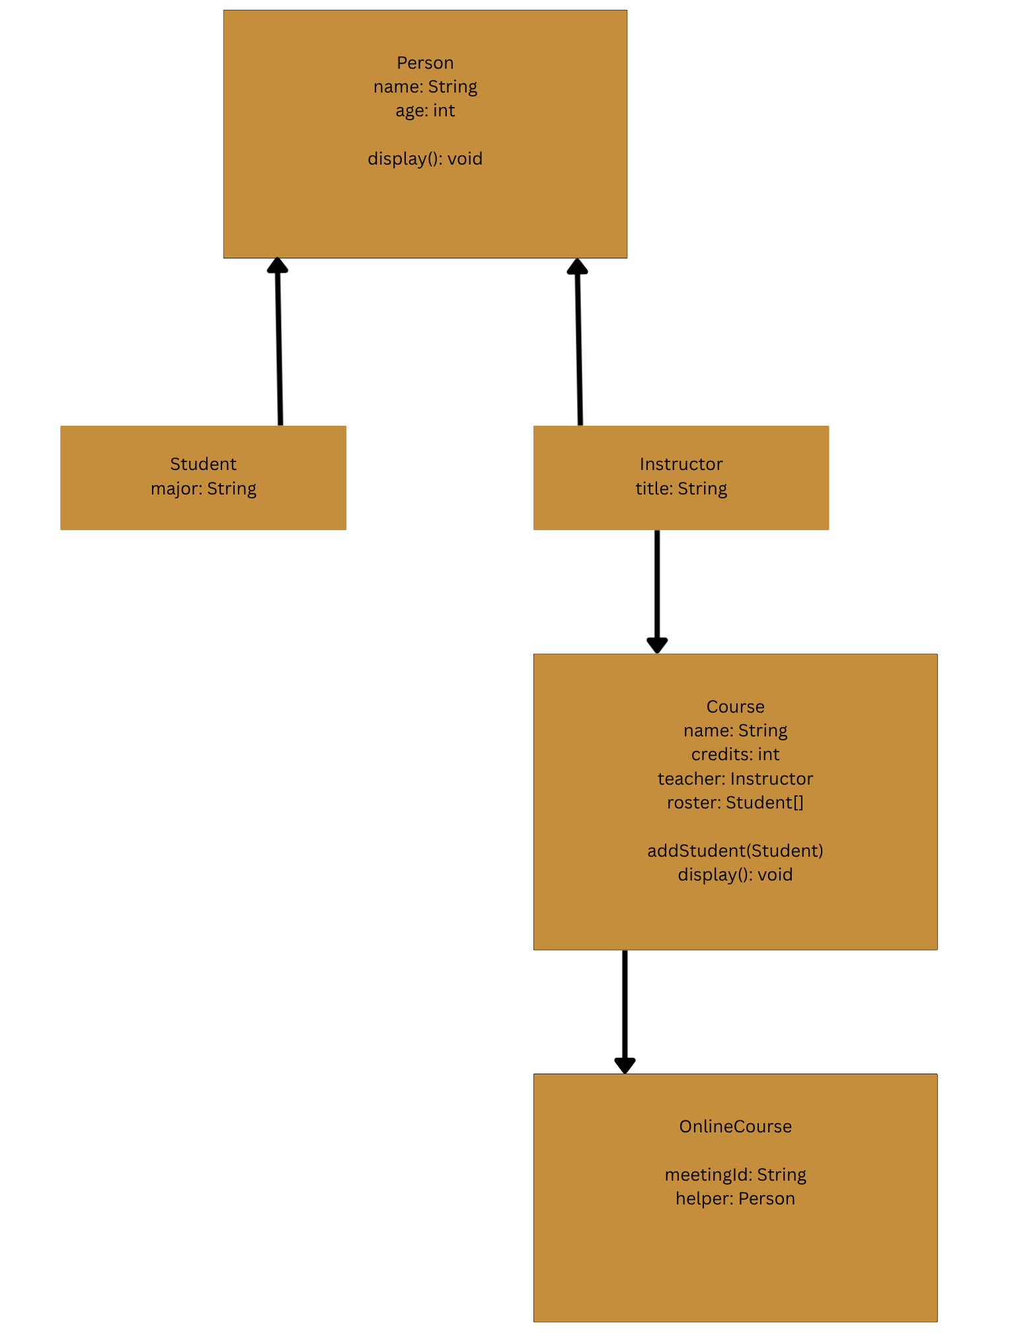

4) Java Collections

A Stack collection is last in first out implementation, consider a stack of plates you would take from the top, meaning the most recently added item is removed first.
A Queue collection is first in first out implementation, consider a line of people to get into a concert, you take the first person in line.

5) SDLC

The advantages of having the SDLC is that it provides a structured way to test software before putting out the wild, it should go through the wringer. SDLC will ensure that all necessary steps are followed and that the final product meets the requirements and acceptance criteria. It will help to identify any potential issues early in the development process,
reducing the risk and bad reputation.

6) Version Control

I use a Mac, so I ran these following commands. Since it’s a virtual environment I don’t have to change anything in my python files, dependencies are isolated. These commands setup the environment, install the deps and save it to a text file that I can call later.

```
python3 -m venv env
source env/bin/activate
pip install numpy==1.18.5 xlwt==1.3.0
```

To deactivate it run `deactivate`

To call it again `source env/bin/activate`

7) Profiling

Before running the code at face value, the check function looks to be doing the most its O(n^2) because of the nested loops. But what’s calling it is the layer function. Layer is doing a depth first search over all possible matrices and check is getting called every time counting each 0 and 1 in every column. So, backtracking would be my real solution keeping track of what was already counted instead of starting over each time. But I’d try to optimize the layer function.

8) SDM

Waterfall is defined as a simple approach that is not flexible enough for projects that need adjustments along the way.
Agile is not the answer because it is considered the most flexible and is made for catching mistakes and errors in the early stages.
DevOps is not the answer because it is a mix of both lean and agile so not this one which means it’s flexible.
Lean is the answer which has a strategy of "don't do today what can be done tomorrow" which means it’s not flexible enough for changes during the project which is Waterfall.

